Algorithm and Programming

Final Project Report

Lecturer:

Jude Joseph Lamug Martinez, MCS

Student:

2702400400 - Angelo Cascino

**1 - Brief description**

The purpose of this app is basically to create a classic Tetris game. As opposed to the one’s that are downloadable from mobile phones, which when internet is connected is filled with ads. This one instead recreates a more classic experience without any ads.

**2 - Use case diagram**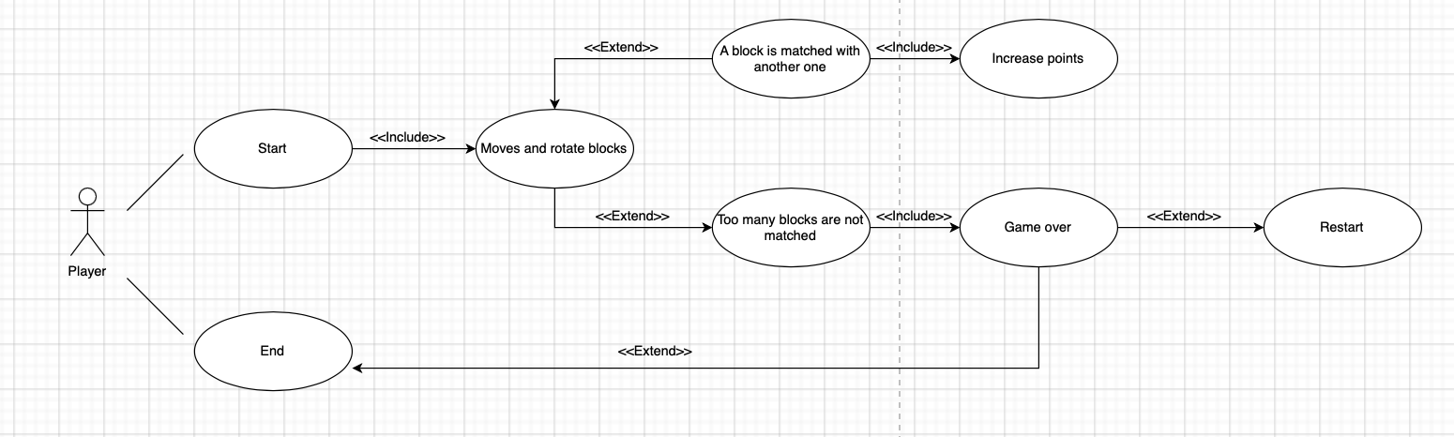

**3 - Activity Diagram**

# Screenshot 2024-01-24 at 03.27.18.png

**4 - Class diagram**

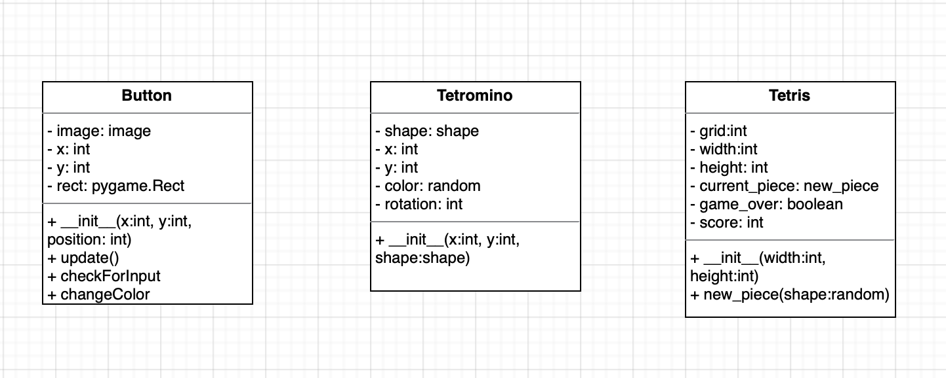

**5 - Modules**

The modules used are:

* sys is a module that provides access to some variables used or maintained by the interpreter and to functions that interact strongly with the interpreter.
* pygame is used to create video games. This library includes several modules for playing sound, drawing graphics, handling mouse inputs, etc.
* random used in game to randomise the falling blocks.

6 - Essential algorithms

7 - Screenshots of application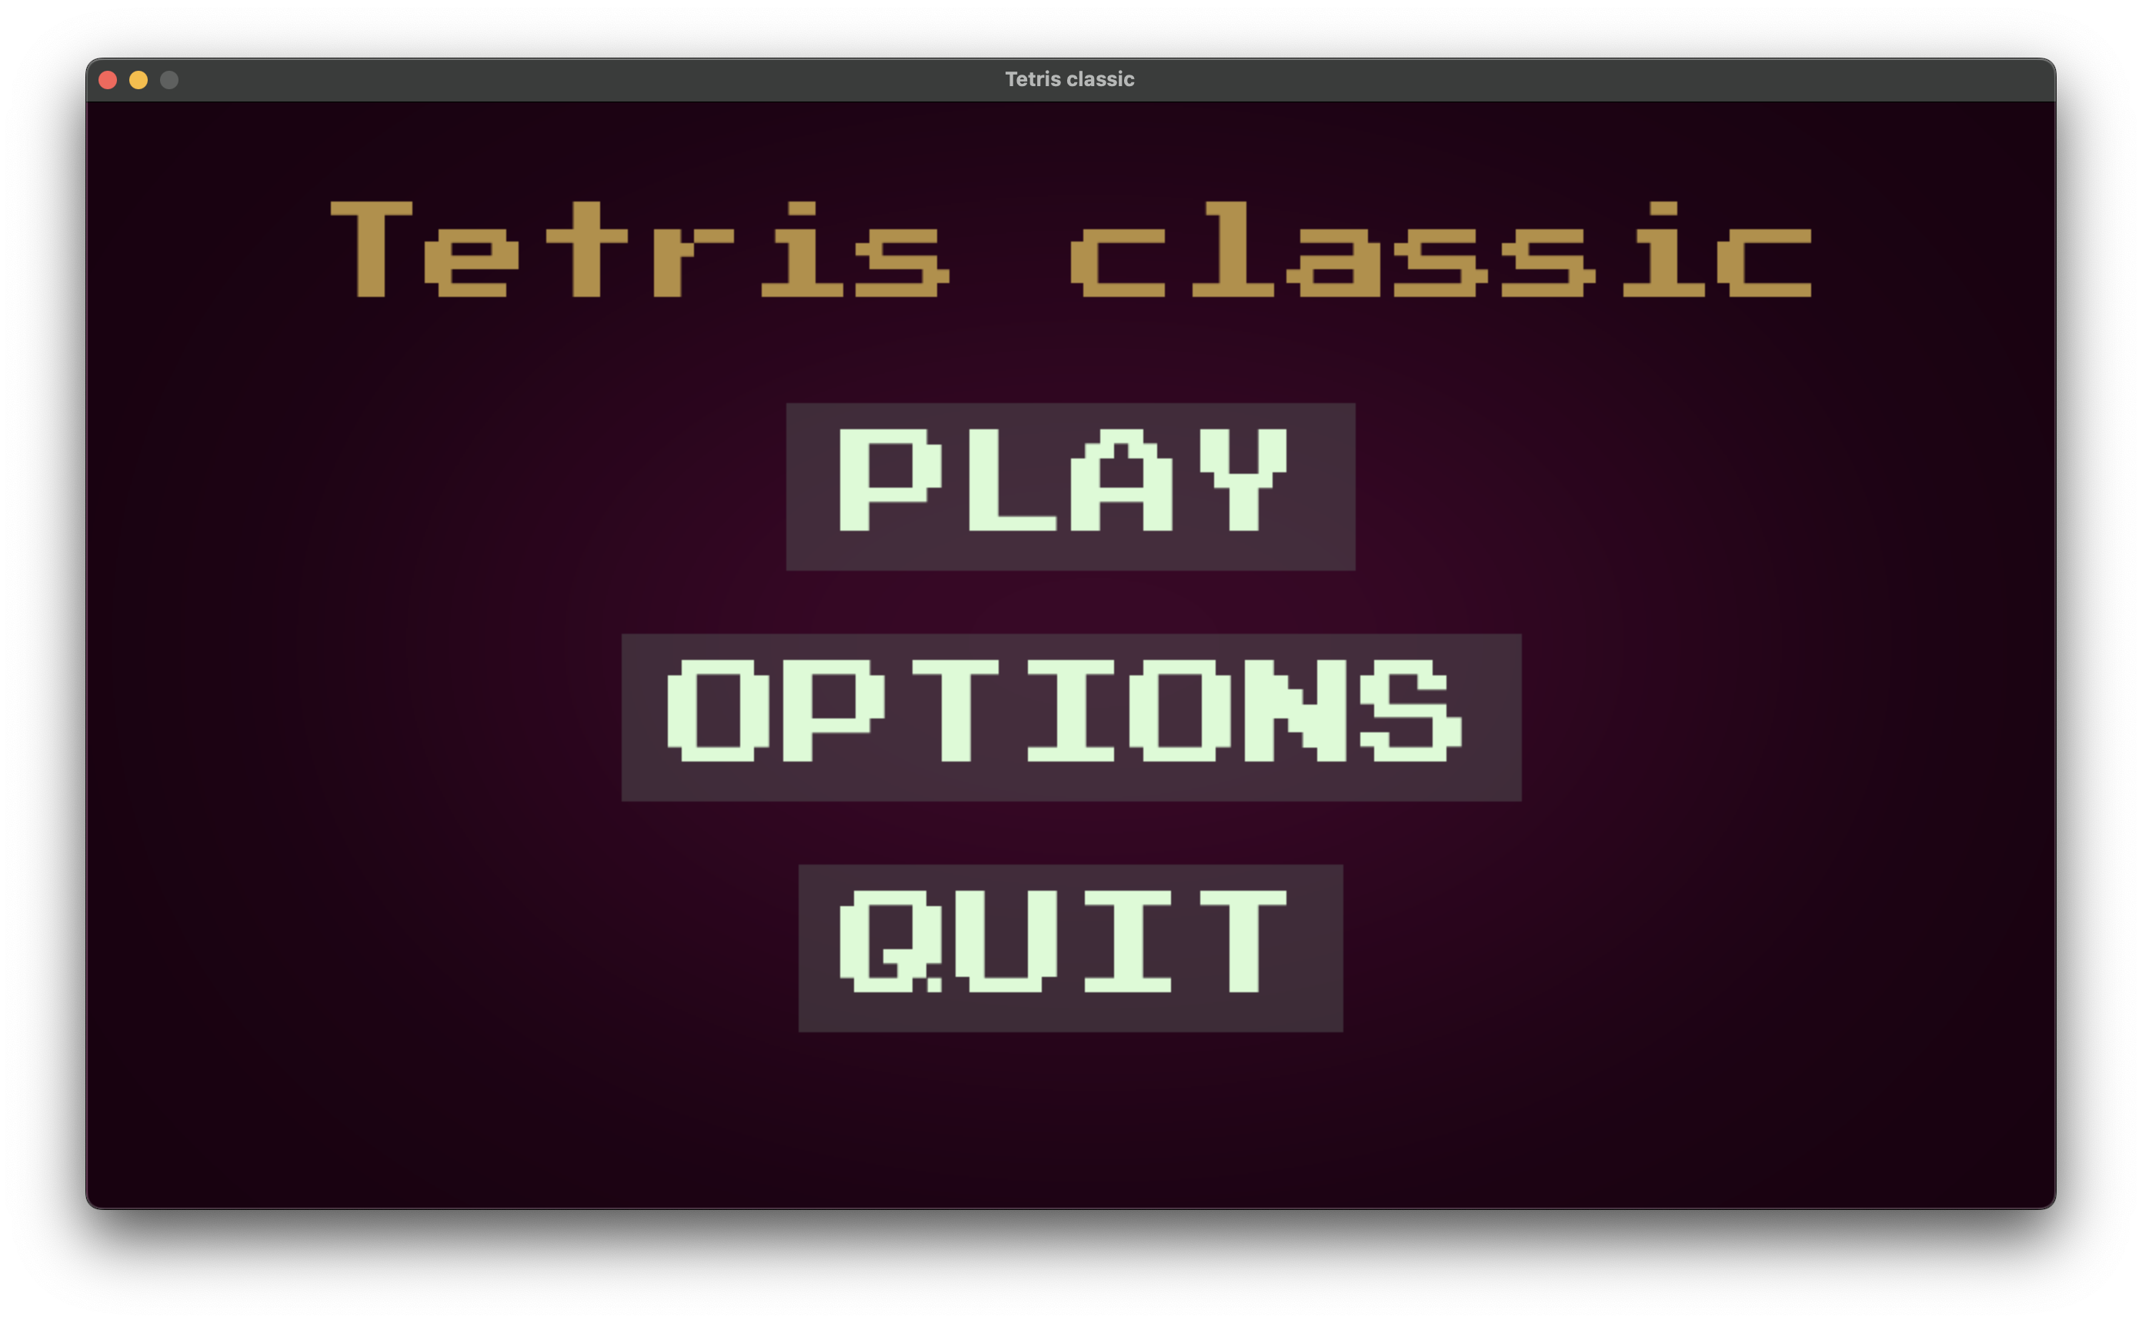

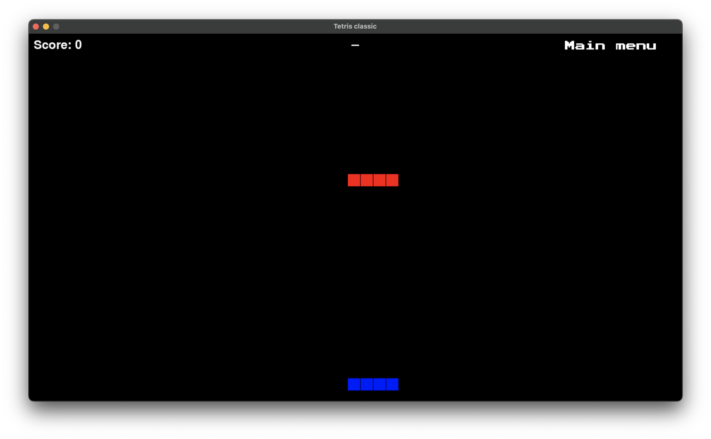

**8 - Reflections**